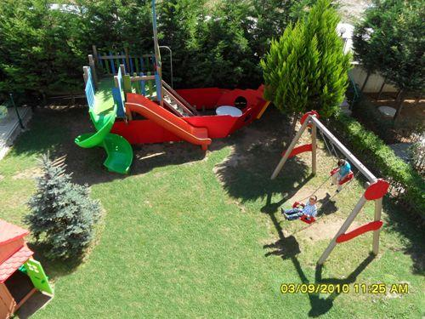
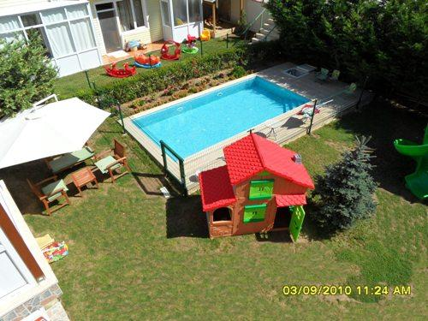
ŞUBAT/2019

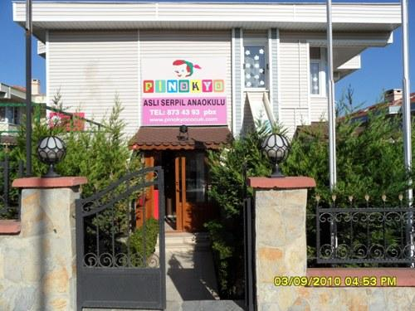

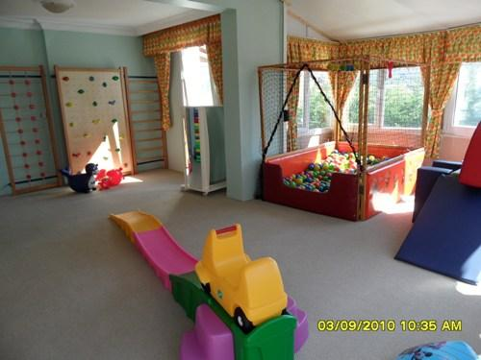
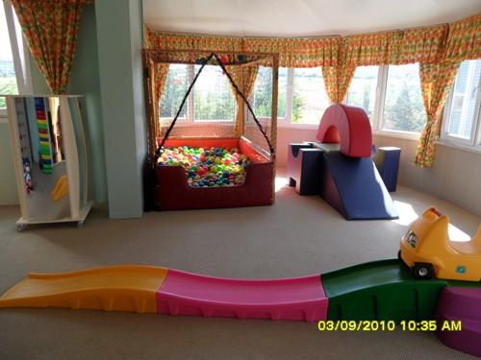

2015-GRUPLARI
BELİRLİ GÜN VE HAFTALAR

ÖĞRENECEĞİMİZ KONULAR
4-8 ŞUBAT
TÜRKÇE, FEN, SANAT: Patates Baskısı Çalışması, Nezaket Kutusu, Su Deneyi, Hayvan Maskesi Yapımı, Yeşili Bulalım Deneyi
OYUN VE HAREKET: Balon Yarışı, Mektup Var, Mendilim Senin Olsun, Tavşanım, Körebe, Kazak Yarışması, Tilki Tilki Saatin Kaç
ÖYKÜ: Üç Küçük Kuzu, Tavşanım, Aslan ile Sivrisinek, Babamla Bir Günüm, Tik Tak PARMAK OYUNU: Ben Kimim TEKERLEME: Babam Yoğurt Getirdi ŞARKI: Gel Oyna, Telefon, Tavşanım ŞİİR: Yeşil BİLMECE: Oyuncak, Araba, Bebek, Çocuk
11-15 ŞUBAT
TÜRKÇE, FEN, SANAT: Sürpriz Zarf, Dereden Geçelim, Eğlenceli Köpükler, Bizi Koruyan Giysiler, Su Damlası, Ağır mı? Hafif mi?
OYUN VE HAREKET: Torbadakini Tahmin Et, Balık Yakalama, Hızlı Yavaş Oyunu DRAMA: Balık ÖYKÜ: Sürpriz Ev, Balık Tutalım, Ormandaki Oyun Parkı, Şemsiyeler, Günaydın Toprak
TEKERLEME: Dedem Elma Getirmiş PARMAK OYUNU: Askerler ŞARKI: Sağlıklı Yaşa ŞİİR: Büyüklere Saygı BİLMECE: Ayaklar, Saçlar, Tırnaklar
18-22 ŞUBAT
TÜRKÇE, FEN, SANAT: Önce Sonra, Yıkamadan Yeme, Duyguların Keşfi, Duyu Organlarımız, Canlı Cansız, Benim Adım Pembe
OYUN VE HAREKET: Topları Toplayalım, Seksek, En Hızlısı Kazansın
DEĞERLER EĞİTİMİ: İYİLİK VE HOŞGÖRÜ
DRAMATİZASYON: Karpuz Tarlası ÖYKÜ: Üzgün Sebzeler, Ayakkabılarım, Ördeğim, Dişlerim, Meyveler TEKERLEME: Bir Cam PARMAK OYUNU: Yıkamadan Yeme ŞARKI: Hoş Gör Sen ŞİİR: Mina ile Sina, Büyüklere Saygı BİLMECE: Şeker, Buz, Çikolata
25-28 ŞUBAT
TÜRKÇE, FEN, SANAT: Saklanma Sanatı (deney)
OYUN VE HAREKET: Hareketli Şekiller,
ÖYKÜ: Balon Arkadaş, Bir Tırtılla Tanıştım, Parmak Çocuk, Kibirli Yaprak, Karınca Bubu
TEKERLEME: Ayşe PARMAK OYUNU: Erken Yatarım ŞARKI: Say Bak ŞİİR: Elektrikli Eşyalar BİLMECE: Ekmek, Yumurta, Pasta

ÖĞRENECEĞİMİZ KAVRAMLAR

SAYI/SAYMA: 1-2 3-4-5 sayıları
RENK : Sarı, Kırmızı, Mavi, Mor, Pembe, Kahverengi
DUYU: Sıcak-Soğuk
DUYGU: Güzel, Mutlu-Üzgün, Kızgın, Korkmuş, Şaşkın
YÖN/MEKANDA KONUM: Başlangıç-Bitiş, İçinde-Dışında, Aşağı-Yukarı, Altında-Üstünde, Önünde-Arkasında, Başta-Sonda
BOYUT: Büyük-Küçük
ZIT: Artrırma-Eksiltme, İnmek-Çıkmak, Açık-Kapalı, Benzer-Farklı, Saygılı-Saygısız, Kışlık-Yazlık, Hızlı-Yavaş, Ağır-Hafif, Önce-Sonra, Kirli-Temiz, Sağlıklı-Sağlıksız, Canlı-Cansız, Buruşuk-Düz
MİKTAR: Az-Çok
GEOMETRİK ŞEKİL: Üçgen, Dikdörtgen, Kare,

2014 GRUPLARI
BELİRLİ GÜN VE HAFTALAR

ÖĞRENECEĞİMİZ KONULAR
4-8 ŞUBAT
TÜRKÇE, FEN, SANAT: İkiz Kelebekler, Sıcaklık Ölçme, Önünde Arkasında, Doğru Yanlış, Kenar Köşe Kavramları, Parmak Boyası Çalışması, Örüntü, Kirli Temiz Deneyi, Eşleştirme, Yumuşak Tüyler
OYUN VE HAREKET: Köşe Kapmaca
ÖYKÜ: Kelebek ve Uğur Böceği, Zıpzıp Tavşan, Benek Benek Kelebek, Rüzgarın Yaramazlığı, Bremen Mızıkacıları
TEKERLEME: Sert-Yumuşak PARMAK OYUNU: Oyun Arkadaşı ŞARKI: Mutlu Çocuk ŞİİR: İki Havuç BİLMECE: Telefon, Ev, Gölge, Masa
11-15 ŞUBAT
TÜRKÇE, FEN, SANAT: Hayvanlar ve Yavruları, Altıgen, Islak Kuru Deneyi, İçinde Dışında Deneyi, Altında Üstünde Çalışması, Benim Adım On, Eğlenceli Köpükler
KUKLA TİYATROSU: Hayvanların Üremeleri DRAMA: Mikroplara Karşı Neler Yapabiliriz, ÖYKÜ: Hayvanat Bahçesi, Minik Kuşun İsteği, Tavşanım, Cemil park Gezisinde, TEKERLEME: Sıfır, On PARMAK OYUNU: Tren ŞARKI: Farecik ŞİİR: Büyüklere Saygı BİLMECE: Balık, Kedi, Kuş
18-22 ŞUBAT
TÜRKÇE, FEN, SANAT: Uyku Arkadaşım, Pembe Deneyi, Kalabalık Tenha Çalışması, Tulumbacı
OYUN VE HAREKET: Gece Gündüz Oyunu, Topları Toplayalım
ROND: Değirmenci Baba ÖYKÜ: Uyku Arkadaşım, Beyaz Kağıt, Renkli Toplar, Oyuncu Civcivler, Eşini Seç TEKERLEME: Hareketli ve Akıllı PARMAK OYUNU: Ellerim ŞARKI: Tulumba ŞİİR: Nezle BİLMECE: Bulut, Portakal, Ay, Elma

25-28 ŞUBAT
TÜRKÇE, FEN, SANAT: Ormanlar Bizim, Kolay Zor, Açık Kapalı, Ağır Hafif Çalışmaları, Trafik Işıkları
OYUN VE HAREKET: Kulaktan Kulağa, Müzikli Sandalye
ÖYKÜ: Ormanları Koruualım, Ağaçların Sohbeti, Oğaçların Yararları, Ormanın Gerçek Sahipleri TEKERLEME: Ben Bir Ağacım PARMAK OYUNU: Orman ŞARKI: Taşıtlar ŞİİR: Orman BİLMECE: Yaprak, Balta, Ağaç

ÖĞRENECEĞİMİZ KAVRAMLAR

SAYI/SAYMA: 1-10 arası sayılar, 1-20 arası sayı sayma, Sıfır Sayısı
RENK : Sarı, Kırmızı, Yeşil, Mavi, Turuncu, Beyaz, Pembe
DUYU: Sert-Yumuşak, Kaygan-Pütürlü, Islak-Kuru
YÖN/MEKANDA KONUM: Alt-Üst, Önünde-Arkasında, İçinde-Dışında, Altında-Üstünde, Yukarı-Aşağı, İleri-Geri
MİKTAR: Az-Çok, Yarım-Bütün, Ağır-Hafif
BOYUT: Büyük-Küçük
ZIT: Aynı-Farklı, Faydalı-Zararlı, Doğru-Yanlış, Canlı-Cansız, Kirli-Temiz, Saygılı-Saygısız, Karanlık-Aydınlık, Kalabalık-Tenha, Kolay-Zor, Açık-Kapalı,
GEOMETRİK ŞEKİL: Üçgen, Kare, Daire, Çember, Kenar, Köşe, Altıgen, Dikdörtgen, Elips
AYIN ÜLKESİ
İSPANYA

2013-GRUPLARI
ÖĞRENECEĞİMİZ KONULAR
4-8 ŞUBAT
TÜRKÇE, FEN, SANAT: Gazeteden Giysiler, Merhamet Etmek, Renkli Lego Karışımı, Dikkat Çalışması, Siyah Beyaz Ortak Olmuş, Nezaket Kutusu, Şekil Çocuk, Ses Çalışması OYUN VE HAREKET: Balonlar Yarışıyor, Kim yok ve Kabak Oyunu DEĞERLER EĞİTİMİ: Merhamet Etmek
KUKLA TİYATROSU: Aslan ile Fare ÖYKÜ: Yaralı Kuş, Ben Bir Kelebeğim, Misafirimiz, İyi ki Doğdun Bonbon, Aslan ile Tilki
TEKERLEME: Komşu Komşu, Şaka Maka, Küçük Dostum PARMAK OYUNU: Dokuz Arkadaş, Erken Yatarım ŞİİR: İki Yuva, Oyun Evi ŞARKI: Merhamet Etmek, Küçük Kurbağa, Küçüğüme Öğüt BİLMECE: Balık, Kelebek, Kuş, Tavşan, İnek
11-15 ŞUBAT
TÜRKÇE, FEN, SANAT: Bilmece Bildirmece, Benim Adım Dokuz, Resim Tamamlama, Tek mi? Çift mi? Çiçek Yaprak Deseni, Doğruluk, makarna Yapıyoruz, Sütün Yararları, Bayram Çikolataları, Topraktaki Gizli Hazineler, Ses Çalışması DRAMA: Hayal Gücü Çalışması ÖYKÜ: Beş Beyaz Baykuş, Vatan Sevgisi TEKERLEME: Benim Adım Dokuz PARMAK OYUNU: İnsanlar ŞARKI: Tanışma, Farecik ŞİİR: Süt, Çocuk ve Güneş, Besinler BİLMECE: Peynir, Uçurtme, İnek, Çiçek, Süt
18-ŞUBAT
TÜRKÇE, FEN, SANAT: Ay Kurabiyeleri, Meslekler Albümü, Hayali Fırçalar, Ses Çalışması OYUN VE HAREKET: Eğlenceli Semboller, Kapana Sıkışan Ceylanlar, Üçgenin Kenarları DRAMA: Özgür Karakaçan, Mikrofonlar Konuşuyor TEKERLEME: Kapaklar PARMAK OYUNU: Yıkamadan Yemeyelim ŞARKI: Uçurtma Şenliği, Meslekler ŞİİR: Tombul Rüzgar, Papatyalar
25-28 ŞUBAT
TÜRKÇE, FEN, SANAT: Yağmur Deneyi, Minik Futbolcular, İlkbahar, 10 Çiziyorum, Ses Çalışması OYUN VE HAREKET: Pedal Çevir DRAMA: Bencil Dev ÖYKÜ: TEKERLEME: Bak Gidiyor On PARMAK OYUNU: Açıp Kapa, Benim Bir Güzel Bahçem Var ŞARKI: Bahar Çarkıcı, Uçurtma ŞİİR: İlkbahar, Sayılar BİLMECE: Sporcu, Orman, Toprak, Gökkuşağı, Yağmur, Şemsiye

ÖĞRENECEĞİMİZ KAVRAMLAR
SAYI/SAYMA: 1-10 Sayıları, 1-20 sayı sayma. Toplama, Tek-Çift
RENK : Kırmızı
MİKTAR: Az-Çok, Bütün-Yarım
BOYUT: Büyük-Küçük, Uzun-Kısa, Şişman-Zayıf
ZAMAN: Erken-Geç, Önce-Sonra
DUYGU: Merhamet, Şevkat, Mutlu-Üzgün-Kızgın, Şaşkın, Mutsuz
ZIT: Arttırmak-Eksiltmek, Hızlı-Yavaş, Ağır-Hafif, Derin-Sığ, Canlı-Cansız, Aynı-Farklı, Tembel-Çalışkan, Açık-Kapalı, Kirli-Temiz, Sağlıklı-Sağlıksız, Düz-Eğri, Doğru-Yanlış, Kolay-Zor
YÖN/MEKANDE KONUM: İçinde, Yüksek-Alçak
GEOMETRİK ŞEKİL: Kare, Üçgen, Daire, Çember, Köşe
AYIN ÜLKESİ

AYIN ŞEHRİ
MARDİN

BELİRLİ GÜN VE HAFTALAR

İNGİLİZCE
FEBRUARY CURRICULUM FOR AGE 4

Week: Language Focus: Concept focus: Songs:
1 | This week the learners will be immersed in the language of road safety.  Key word for the week is ROADS.  Repeated words: cross, lights, stop, look and listen. | Numbers: 1-2-3-4-5-6  Shapes: Circle Triangle Square Rectangle  Colours: Red Yellow Green  Position: Under Over Between  Opposites: Stop/Go | Traffic Lights  https://youtu.be/PR1NEvdWmmk
2 | This week the learners will be immersed in the language of farms.  Key word for the week is FARM.  Repeated words: animals, plants, tractor, farmer and scarecrow. | umbers: 1-2-3-4-5-6-7-8-9  Colours: Green, orange, yellow, red, blue, purple, pink, white, black, grey, brown  Position: In On | The Animals on the Farm  https://youtu.be/zXEq-QO3xTg
3 | This week the learners will be immersed in the language of farms.  Key word for the week is HEN.  Repeated words: hen, eggs, vegetables, cow and milk. | Numbers: 1-2-3-4-5-6  Shapes: Triangle, Egg Shape  Size: Big Small  Position: In On Under | Old Mc Donalds  https://youtu.be/5oYKonYBujg
4 | This week the learners will be immersed in the language of sheep farming.  Key word for the week is WOOL.  Repeated words: grow, cut, wash, sweater and make. | Numbers: 1-2-3-4-5-6-7-8-9-10  Colours: Green, orange, yellow, red, blue, purple, pink, white, black, grey, brown  Size: Long Short  Opposites: Soft/Hard | Baa Baa Black Sheep  https://youtu.be/7JTmwQI0QDg

FEBRUARY CURRICULUM FOR AGE 5&6
Week: Language Focus: Concept focus: Songs:
1 | This week the learners will be immersed in the language of occupations.  Key word for the week is JOB.  Repeating words: postman, doctor, teacher and fireman. | Colours: Red, orange, yellow, green, blue, purple, pink, grey, black, white  Numbers:1- 10  Shapes: Circle, Rectangle, Square, Triangle  Size: Big, Small  Position: In, Out | Jobs song  https://www.youtube.com/watch?v=ckKQclquAXU
2 | This week the learners will be immersed in the language of climate.  Key word for the week is TEMPERATURE.  Repeating words: fur, feathers, scarf and coat. | Colours: Red, orange, yellow, green, blue, purple, pink, grey, black, white  Numbers:1- 10  Shapes: Circle, Square, Triangle  Size: Long, Short, Big, Small  Position: In, Out  Opposites: Hot/Cold, Wet/Dry | Put on your shoes  https://youtu.be/-jBfb33_KHU
3 | This week the learners will be immersed in the language of heroism.  Key word for the week is HERO.  Repeating words: protect, respect, kind and good. | Colours: Red, orange, yellow, green, blue, purple, pink, grey, black, white  Numbers:1- 10  Shapes: Circle  Position: In, Out, On, Up, Down  Opposites: good/bad | We’re the heroes  https://youtu.be/mbkDSjDmsL0
4 | This week the learners will be immersed in the language of production.  Key word for the week is GROW.  Repeating words: figs, potatoes, apples and aubergines. | Colours: Red, orange, yellow, green, blue, purple, pink, grey, black, white  Numbers:1- 10  Shapes: Circle, Oval  Size: Big Small, Short, Tall  Position: In, Out, Under, On | Vegetable Song  https://youtu.be/-TZ8cSlv1YM
ALMANCA

IN DER SCHULE-OKULUM KLASSEN WÖRTER-ANAOKULU ZAHLEN-SAYILAR
Leise | Sessiz
Laut | Sesli (gürültü)
Hinsetzen | Oturmak
Aufstehen | Ayağa Kalkmak
Sasummun Spielen | Birlikte Oynamak
Lernen | Öğrenmek
Kindergarten | Okulum
Lehrer | Öğretmen
Schüler | Öğrenci
Klasse | Sınıf
Malen | Resim-Boyama
Singen | Şarkı Söyelmek
Elf | Onbir
Zwölf | Oniki
Drei zehn | Onüç
Vier zehn | Ondört
Fünf zehn | Onbeş
Sechs zehn | Onaltı
Zieb zehn | Onyedi
Acht zehn | Onsekiz
Neun zehn | Ondokuz
Zwanzig | Yirmi

PARMAK OYUNU

Mit fingerchen, mit fingerchen (you tube dinle)

ŞARKI
ŞARKI: Brüderchen, komm tanz mit mir (you tube dinle)
ŞARKI: Alle leut(you tube dinle)

HAREKETLİ OYUN
Wo ist der dow wen (you tube izle ve dans et)

